**Structured Decision Modelling for Decision making in Human-Elephant Conflict mitigation methods in Thailand.**

Human-Elephant Conflict (HEC), one of the major threats to the conservation of elephant population that happen almost every habitat range of elephant species. HEC caused by overlap of human and elephant habitat from the anthropogenic expansion. Elephant come out from natural forest and raiding agriculture in the community causing economic lost in the area. Likewise, people retaliate raiding elephant leading to injuries and death to both human and elephant. Losing from both human and elephant prevent on conservation and sustainability development everywhere the conflict happened. Therefore, mitigation methods on this conflict is a need to lower the level of the consequences. There are many mitigation methods have been developed until now. Starting from Physical barriers which construct a wall or fences to prevent from entering agricultural fields such as electric fence, trench, wire fences, and biological fences. Then there is Vigilance methods which focus on alarm people when elephant enter the area to drive them away such as alarm fences. Next is Deterrent methods focusing on repel the elephants such as chili fences and vinegar fences. Another one is Repulsion methods which focus on drive elephant away using noise, firecrackers, throwing things, and fire. Lastly, the alternative methods which have been used differently in each HEC sites such as, supplementary feeding, translocation, ecotourism, land use planning and compensation. Each method has different cost and effect which work effectively in different HEC sites. As A Result, I aim to create a decision analysis in choosing mitigation methods to use in different HEC sites.

In Thailand, the problem of HEC has continue for more than 10 years. This conflict has been widespread, intensively in 5 forest complex of Thailand which are Western forest complex, Kaeng Krachan forest complex, Eastern forest complex, Dong Phayayen-Khao Yai forest complex, and Phu Khieo forest complex. Each site has their specific context that need different management plan to mitigate the problem effectively. Thus, I plan on using SDM as a framework on making decisions on which mitigation methods should be used in different HEC sites. SDM allows us to defining management objectives, potential alternative choices, modelling outcomes of alternatives, and identify solutions.

Objectives are developed based on stakeholders and use as the goals for the management plan. In HEC, the fundamental objectives is reducing HEC level to the point of Human-Elephant co-existence which can be achieve from the means objectives of: Reduce incident/crop depredation, Reduce injury/death, Long-term mitigation, Minimize monetary cost, and Conservation awareness.

Then, alternatives will be evaluated on the objectives. Management alternatives are each mitigation methods that have been used and will be categorized as Physical barriers, Vigilance, Deterrent, Repulsion, Resources improvement, Land use change, Ecotourism, and Capacity building. This will be done using Multi-Criteria Decision Analysis weighing on different mitigation methods that meet objectives. The values for each alternative will get from interview with key stakeholders. The comparisons of each alternatives will show which mitigation methods could be the methods that fit the different objectives and HEC context.

Then after identifying the possible mitigation methods, it will be monitor on the effectiveness and looking on the uncertainty. The uncertainty that we may face when working on this problem are Elephant patterns, natural systems, and community attitude. Elephant patterns could change from time to time as they are smart species that can learn very fast. Natural systems like resources available will lead to HEC occurrence. Elephant relied on available resources so natural resources could give some uncertainty to the management. In community attitude, it effects on the intensity and community engagement in the local area. With a negative attitude, it could lead to more intensity in the area with lower cooperation in the site and the problem will never be solved.

The above uncertainty could be controlled or lower by doing more research and practices. We could study more on the pattern of HEC and resources available in the HEC sites. This could help for more alternatives like resource improvement in the natural habitat. Moreover, we can create more awareness to the local community to create more positive attitude toward HEC. We can start by training and do ecotourism in the area so they could protect the resources they have.

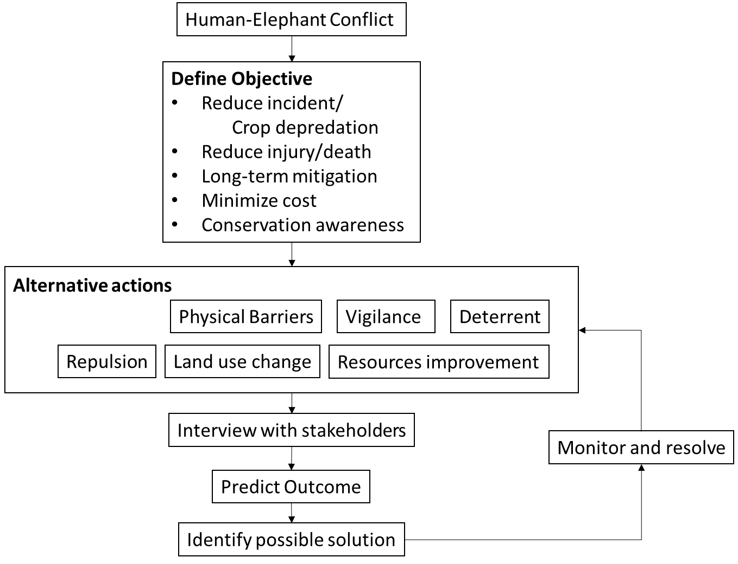

Figure 1 A flow chart of structured decision modelling process. It begins from define objectives, then identify alternative actions, predict outcomes, and identify the possible solutions. Monitoring and resolve will be conducted to see the effectiveness and looking on the uncertainty.

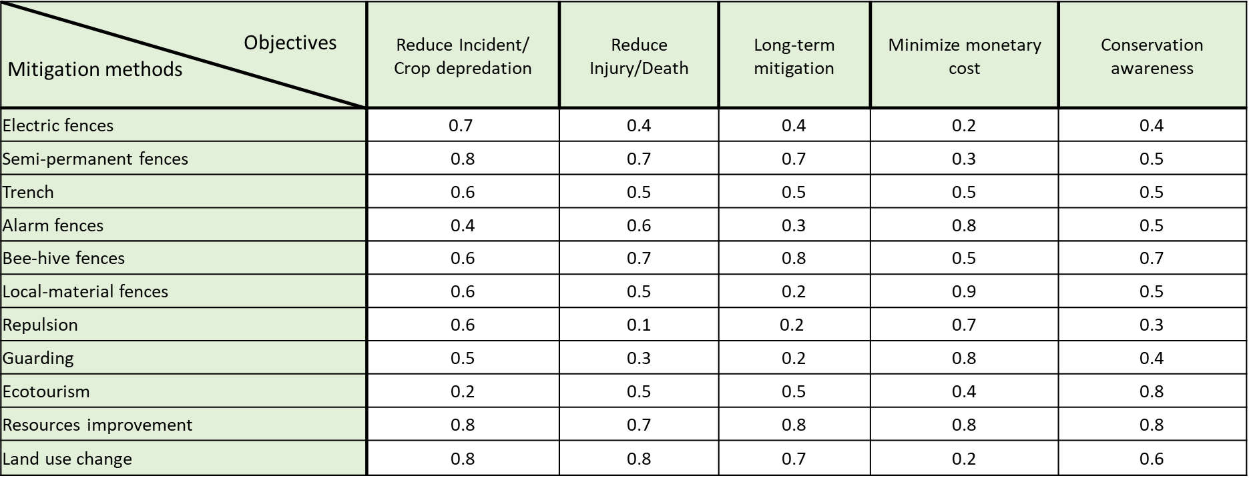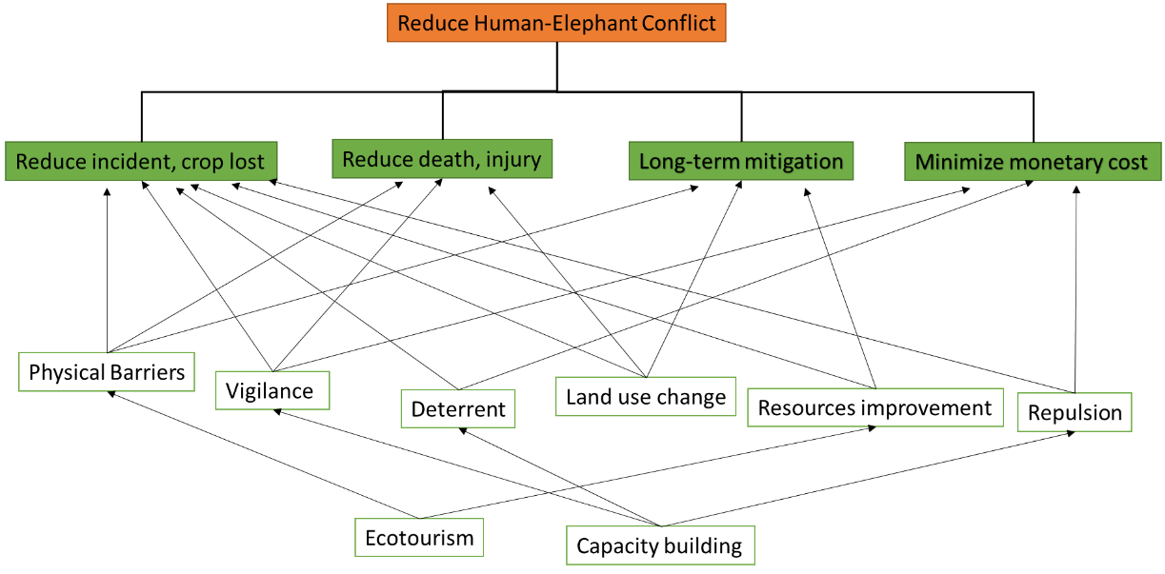

Table 1 This table show the value of each alternative actions to each of objectives. This table will look at the weight comparison using Multi-criteria Decision Analysis to find the suitable actions for different context.

Figure 2 This is the relationship of how each alternate action achieve different objectives